GWPM-09-1800
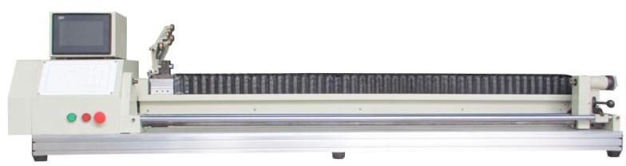
Technical Specification

Product features
1.Using 32 - bit ARM control chip, Cyrines CPLD, the calculation speed is faster, effectively reduce the error of the line.
2.Input and output all photoelectric isolation, stable work.
3.All Chinese liquid crystal display, easy to operate.
4.Intelligent input winding point and line width.
5.Intelligent deceleration of wire commutation ensures faster wire routing and greater torque.
6.Can set the spindle climbing time, real-time change spindle speed, overspeed tracking.
7.Save the winding data after power failure, effectively avoid the scrap of the coil caused by sudden power failure.
8.The position of the cable tray can be adjusted manually during the winding process.
9.Adopt bearing belt imported from Japan, inverter and lead rod imported from Taiwan, cast iron box, ensure stable performance.
10.The tail top shaft rotates synchronously with the main shaft through the transmission device, which can be used for winding copper wire or nickel chromium wire on the thin and long mica sheet and other brittle material carrier.

Range of application
1.Long and thin coil
2.Heat tracing coil
3.Mica plate coil
4.Warm silk coil

Product pictures

The picture is for reference only, the final product varies according to different customer needs.
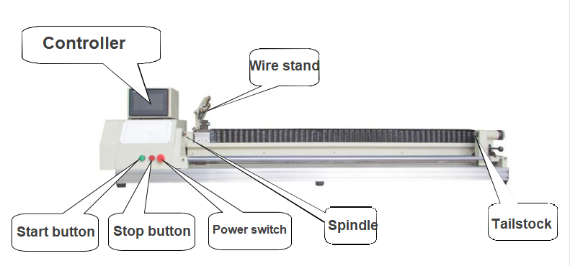

Technical parameters

Spindle NO. | 1
Spindle Speed | 0-1200rpm
Wire Diameter | 0.1-1.8mm(With different torque motor and different tension system, different configuration of different prices)
Swing Diameter | 0-160mm
Traverse Travel | 0-1800mm（Can be customized according to customer requirements 1 meters or 1.5 meters of the model, different trip prices are different）
Wire speed | 0-33mm/S（The wire speed of the servo motor is about 3 times that of the standard stepper motor）
Spindle Motor | 550W Three-phase AC motor +750W frequency converter (this is the standard configuration, the actual choice of appropriate motor according to different wire diameter)
Spreading Motor | The standard configuration is two-phase hybrid stepper motor with static torque of 2n.m. The servo motor can be selected according to the speed required by customers (the price is different for different configurations).
Power Supply | Single phase 220V±10% 50HZ
Machine Power | 900W（This is the standard configuration power. The actual total power varies according to the configuration）
Size | L：2530mm W：450mm H：520mm（This is the length of the 1.8 m stroke model，different strokes, different lengths,the width and height are the same.）
Weight | Different strokes, different weights
Multiple Winding | Changing part of the configuration enables multi-winding

Software functions

Skeleton basic parameter input. Start winding point, Spreading width, Spreading spacing, number of winding turns, start slow train, stop slow train, spindle positioning, spindle low speed, spindle high speed, spindle direction, Spreading direction, layer stop.

Spindle climbing time setting, special winding function selection (as shown below).

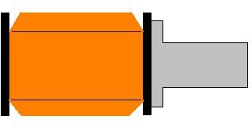
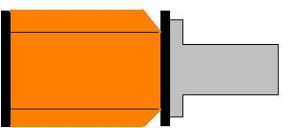

Both ends of the indentation Single indent



Antenna winding

The position of the wire stand can be manually adjusted in the winding process to realize fine tuning of the precision cable arrangement. This function needs to be customized.

The system has 1450 segments of data storage space, which can save up to 999 bobbin parameters. The debugged bobbin parameters can be permanently saved. When replacing the product, only the corresponding fixture needs to be replaced and the corresponding bobbin parameters can be selected.

When the power is suddenly cut off during winding, the system saves the final winding state. After powering on again, press the start button to continue winding the unfinished coil.

Special function can be customized software.

